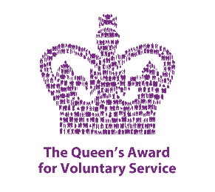 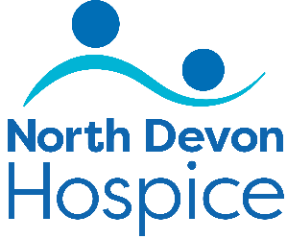

Electronic Donations Tester Volunteer

Role Brief

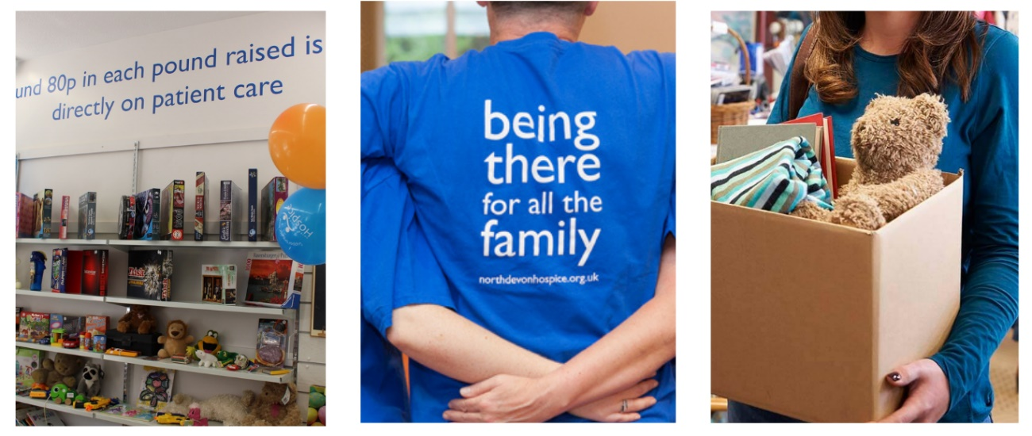

The aim of the role:

We are all about high quality, pre-loved and sustainable retail. Our aim is to maximise income from all our retail activities to raise funds for North Devon Hospice by spotting and exploiting trends. We sell on multiple online platforms worldwide and we are looking for volunteers to help us in various stages throughout the donation journey.

What’s involved:

Testing donated electrical items to ensure they function as intended whilst wiping any personal data from them, before they are listed for sale on our online platforms. For example; mobile phones, DVD players, gaming systems etc.

Please note the items will already be safety PAT tested and no specific electrician skills will be required.

All roles will be subject to guidelines and full training will be given.

Assisting staff where directed and always maintaining a clean and safe environment and to be an ambassador for the hospice at all times. Undertaking any other tasks as requested or appropriate within the nature of the role.

A taster session will be arranged to ensure you understand what your role would entail.

Hours required:

We currently have a number of shifts available, please contact us for details.

**Mornings: 9am – 12:30pm Afternoons: 12:30pm – 4pm**

Commitment to a regular shift, or shifts, per week is preferable.

 What the hospice offers:

¨  A safe, welcoming and supportive environment

“I love the feeling that volunteering gives me - being part of a great team and working towards one goal is really special.”

¨ An induction & full training given on all aspects of the role

¨ Reimbursement of reasonable travel expenses

¨ You will be part of a dedicated and friendly team

¨ The opportunity to utilise existing skills or develop & learn new skills

¨ The opportunity to meet new people

¨ The knowledge you are directly contributing to the care & support offered to our patients and their families we care for

What you can offer us:

¨ An ability to work as part of a team in a busy environment

¨ A friendly, approachable and non-judgemental manner with a good attention to detail

¨ Be able to maintain confidentiality and have an awareness of maintaining boundaries

¨ Good communication skills & an ability to relate to people from all backgrounds

¨ A willingness to undertake training and to follow NDH policies and guidelines

¨ An agreement to follow all Covid related safety & infection control measures

¨ An adaptability to changing trends and requirements