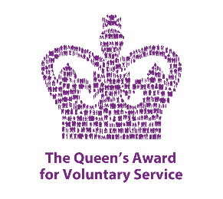 

Packaging Volunteer

Role Brief

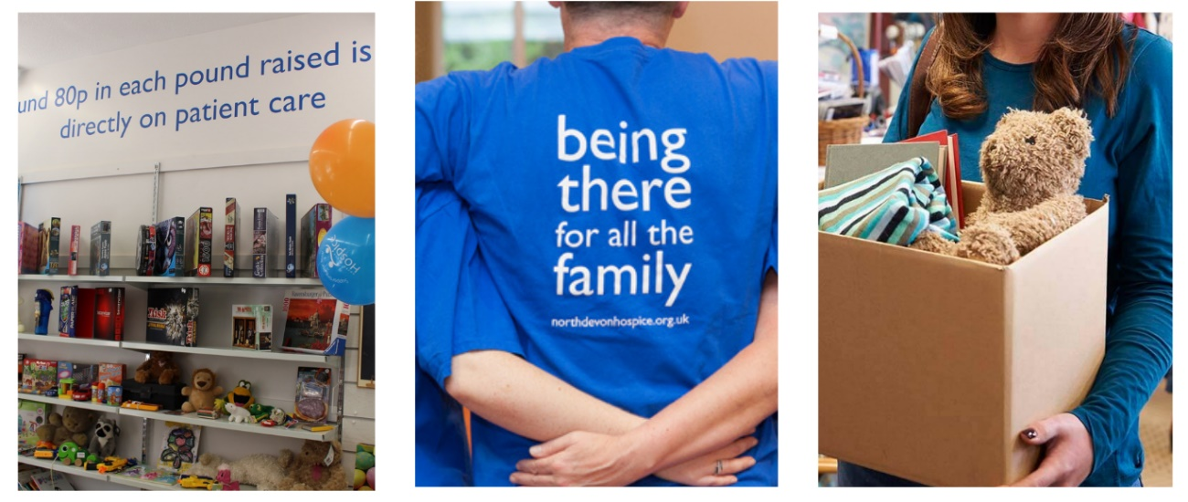

The aim of the role:

We are all about high quality, pre-loved and sustainable retail. Our aim is to maximise income from all our retail activities to raise funds for North Devon Hospice by spotting and exploiting trends. We sell on multiple online platforms worldwide and we are looking for volunteers to help us in various stages throughout the donation journey.

What’s involved:

**Ensuring items that have sold online are securely packaged before shipping to prevent damage during transit.**

All roles will be subject to guidelines and full training will be given.

Assisting staff where directed and always maintaining a clean and safe environment and to be an ambassador for the hospice at all times. Undertaking any other tasks as requested or appropriate within the nature of the role.

A taster session will be arranged to ensure you understand what your role would entail.

Hours required:

We have three shifts available, please contact us for details.

**Tuesday** and/or **Thursday** and/or **Saturday 9am - 12pm**

Commitment to a regular shift, or shifts, per week is preferable.

 What the hospice offers:

¨  A safe, welcoming and supportive environment

“I love the feeling that volunteering gives me - being part of a great team and working towards one goal is really special.”

¨ An induction & full training given on all aspects of the role

¨ Reimbursement of reasonable travel expenses

¨ You will be part of a dedicated and friendly team

¨ The opportunity to utilise existing skills or develop & learn new skills

¨ The opportunity to meet new people

¨ The knowledge you are directly contributing to the care & support offered to our patients and their families we care for

What you can offer us:

¨ An ability to work as part of a team in a busy environment

¨ A friendly, approachable and non-judgemental manner with a good attention to detail

¨ Be able to maintain confidentiality and have an awareness of maintaining boundaries

¨ Good communication skills & an ability to relate to people from all backgrounds

¨ A willingness to undertake training and to follow NDH policies and guidelines

¨ An agreement to follow all Covid related safety & infection control measures

¨ An adaptability to changing trends and requirements